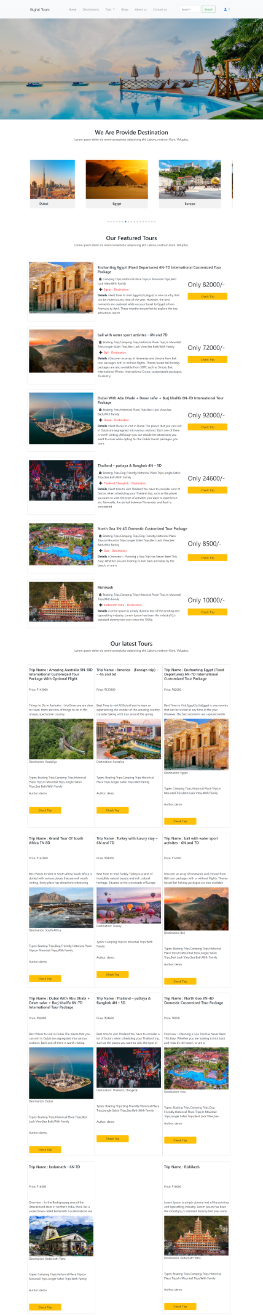

DROWBACK OF GUJRAT TOURS WEBSITE PROJECT

* WE CAN NOT FILTER TRIP WITH ASIDE MULTIPLE OPTION LIKE AN

1. Trip price
2. Trip Destination
3. Trip Categorieys

* WE CAN NOT CREATE ADMIN USING USER LOGIN PAGE